OPERA RE-DESIGN 5

Company Database
Background colours, font size, button colour etc. to match existing developments on all the pages below. Link from AMGM logo to home page to be retained.

Edit Company - 005CompanySearchOut.aspx
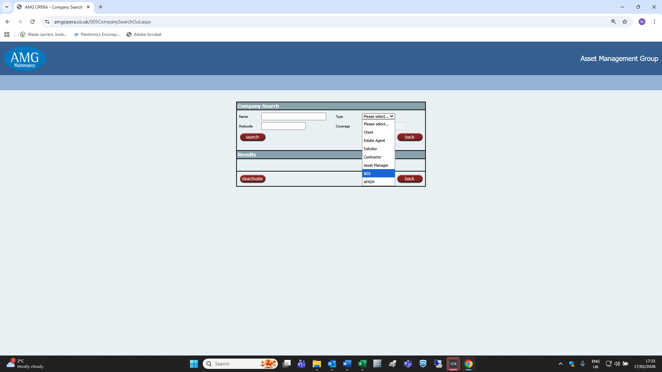
Remove REX from list of company types.
Remove Coverage field (hidden behind the company type drop-down list in the screenshot above). This is currently greyed out and inoperable.
Move Postcode field to current location of the Coverage field.
Add Town field to current location of the Postcode field.

005EditCompanyIn.aspx
Attempting to access this page results in the following error message:
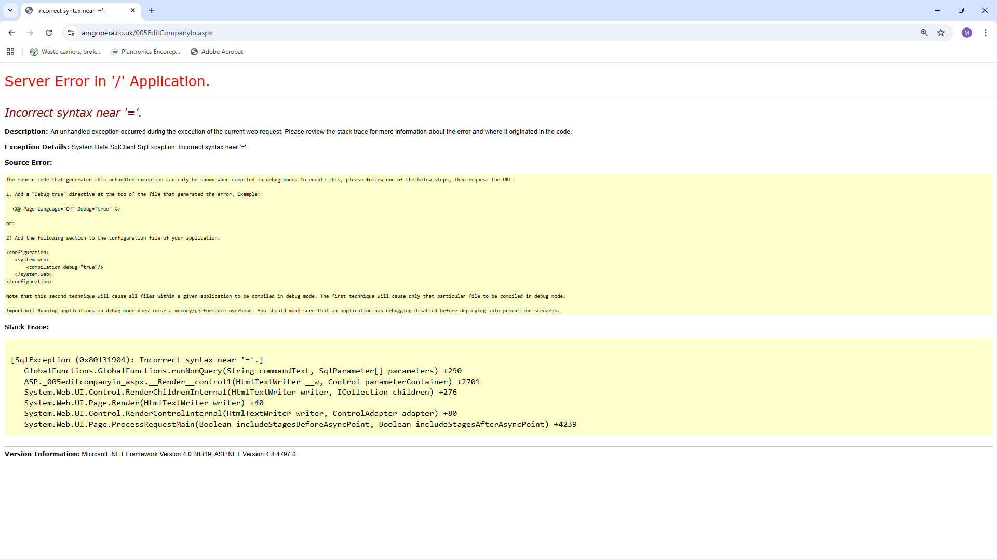
Any ideas?

Add Company - 005EditCompanyOut.aspx
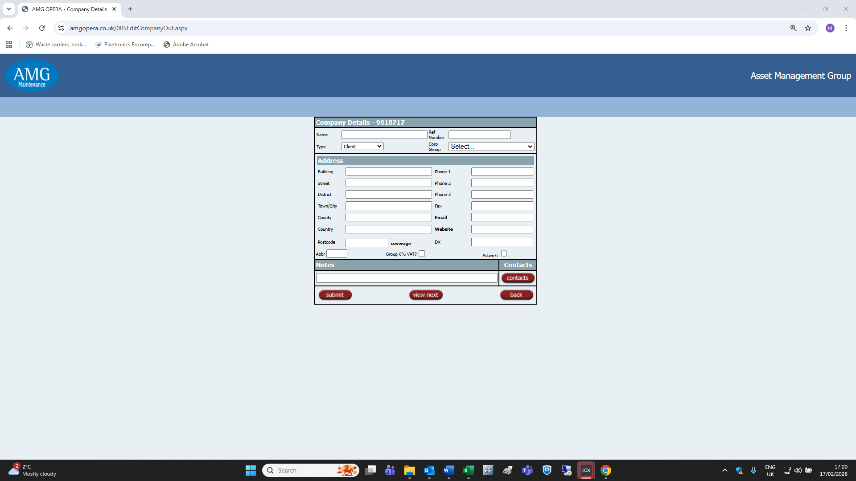
Remove Country field from the lefthand column and both Fax and DX fields from the righthand column.
005EditCompanyOutPop.aspx appears to be a duplicate for the above. Is this page redundant?
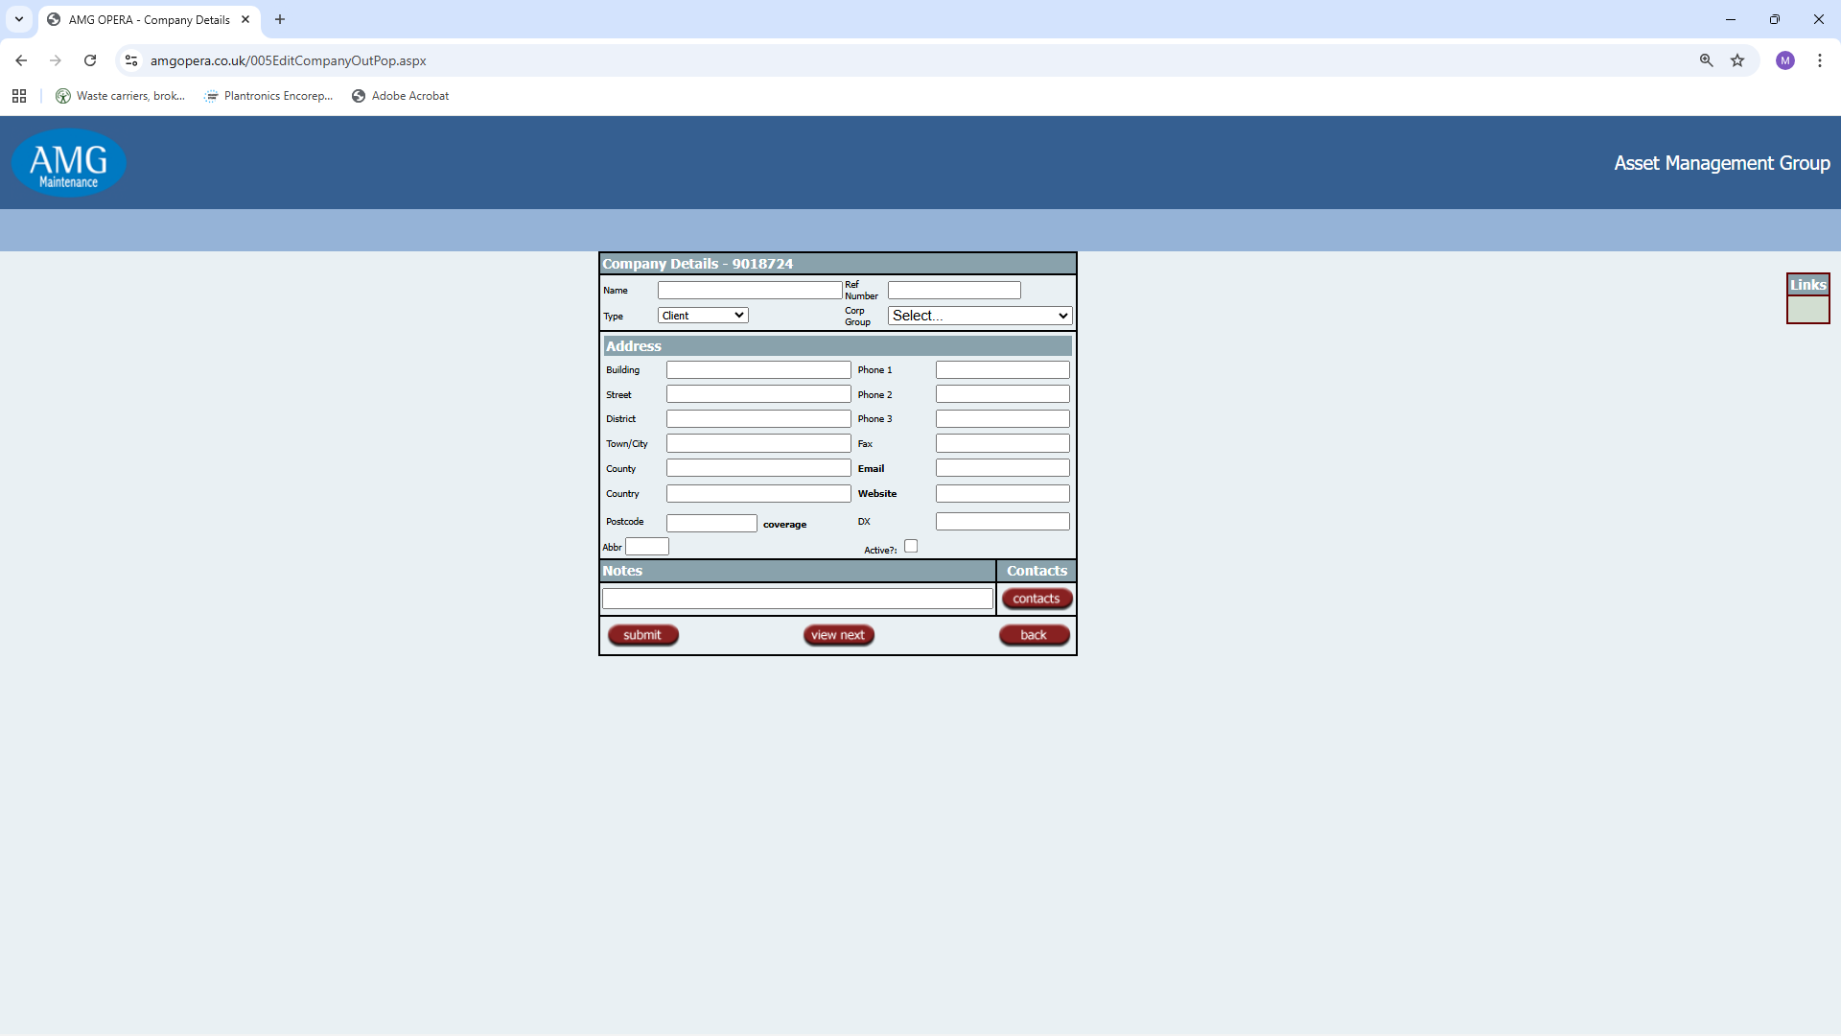

005ContractorDetailsOut.aspx
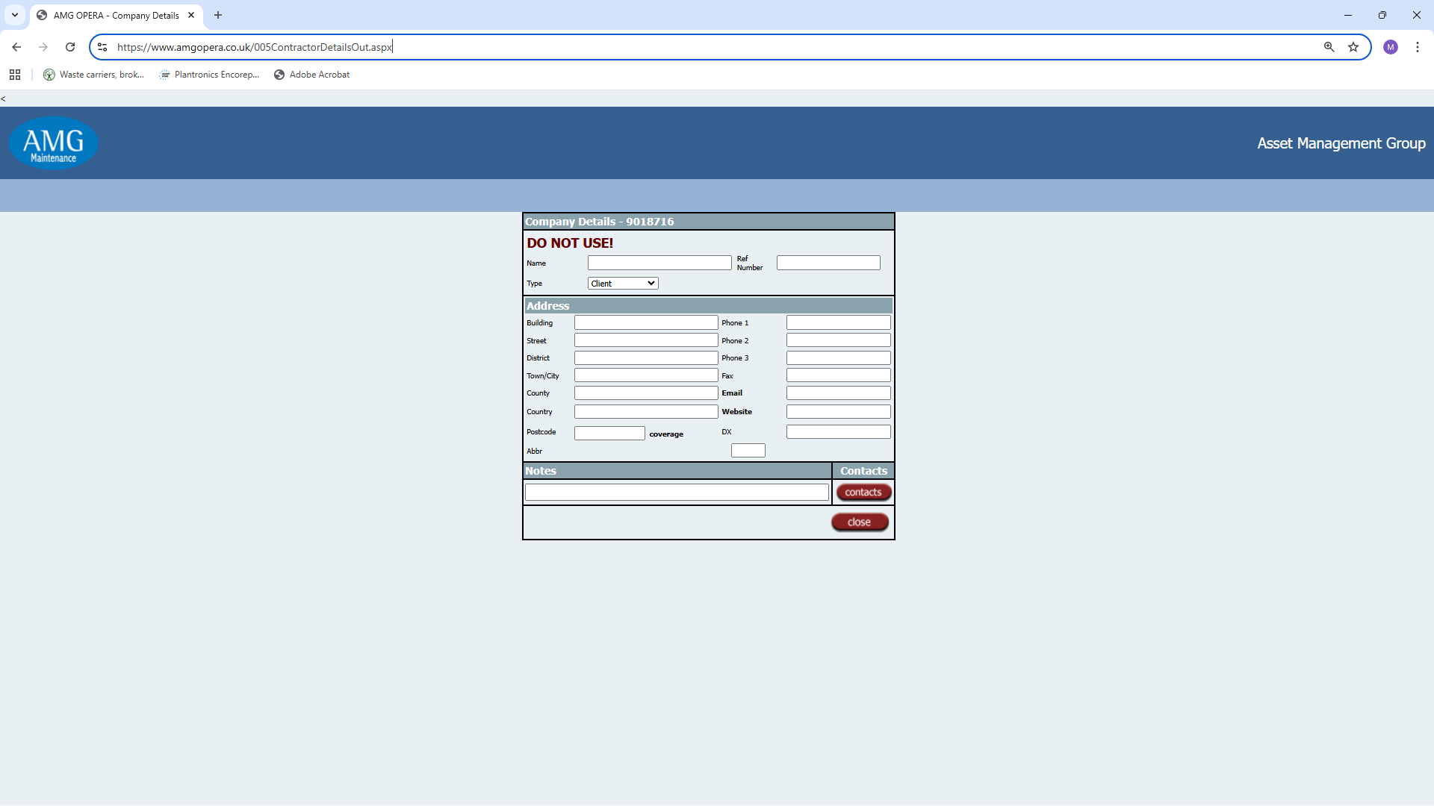
I think that this dates from the original transfer of the TESSA estate agent database to OPERA. On the basis that TESSA users will only allocate an estate agent that can be used, is this page redundant on OPERA?

List Company - 005CompanySearchOutPop.aspx
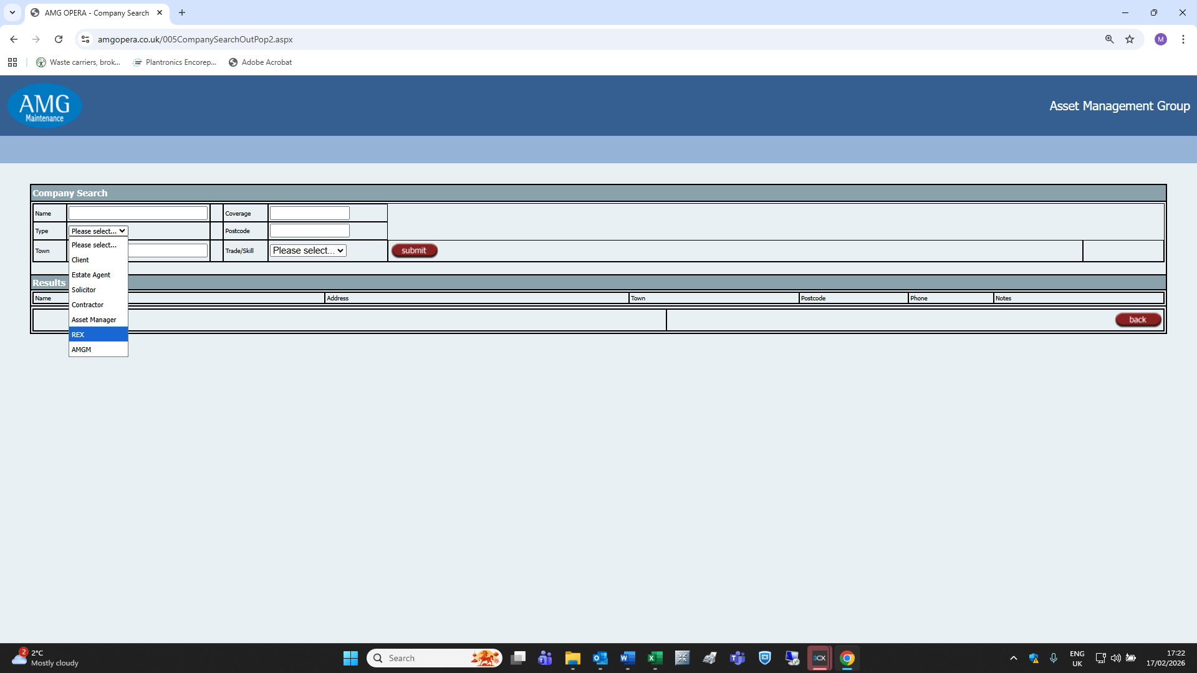
Remove REX from list of company types.

005CompanySearchOutPop2.aspx appears to be a duplicate for the above. Is this page redundant?

005GroupDeactivate.aspx I am unable to access this page and am redirected to 005CompanyMenu.aspx when I try. Any ideas?

005ListCompanyOut.aspx
Attempting to access this page results in the following error message:
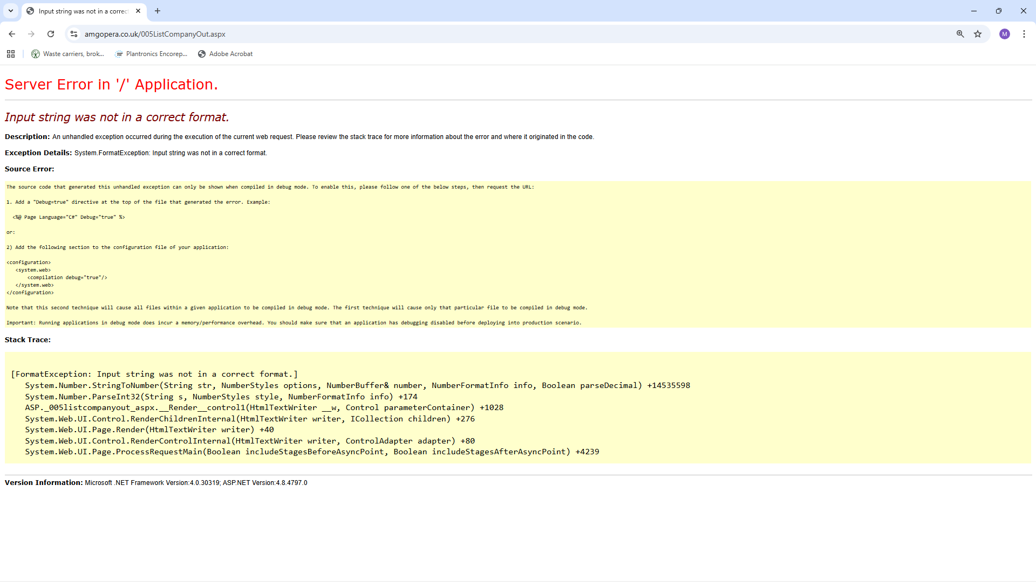
Any ideas?

